Media Literacy



English 1201

Name: ____________________________________________________________________________

MEDIA LITERACY - General Terms

Media – forms of public communication (such as newspaper, radio, television, information network, poster, or brochure) that is designed to reach large numbers of people.
Media Literacy – evaluating media texts for comparison, message, intended audience, etc.
Advertisement – the promotion of goods or services for sale through impersonal media, such as radio or television; the physical promotion of a product (commercial or magazine)
Agenda – a list or program of things to be done or considered; could also mean the purpose or motive behind a media text
Blog – a website that contains an online personal journal with reflections, comments, and often hyperlinks provided by the author
Brochure – a booklet of printed informational matter, like a pamphlet, often for promotional purposes
Caption – the words beneath a photograph that explain the subject and give background information; help to shape the meaning of the photo, sometimes in misleading ways
Commercial – a public promotion of a product or service
Deconstruction – breaking a text down into its components to see what messages and assumptions it carries
Demographic – a portion of a population, especially considered as consumers
Endorsement - a message issued on behalf of some product, cause, idea, person, or institution; usually involves companies and their products
Format – style, plan or arrangement
Form – smaller division within a genre (Ex: poetry is a genre; haiku, a type of poetry, is a form of the genre)
Headline – the heading, title or caption of a newspaper article; usually very attention-grabbing.
Icon – in media, it can be referred to as an image; in literature, it is known as a description of a person or thing, usually using a figure of speech
Image – an object that usually represents a larger idea
Intent – an aim or purpose
Lead – the introductory section of a news article/story; usually a news story of major importance in a newspaper
Logo – an identifying symbol used to advertise and promote an organization, event, product or service. Usually, such symbols combine pictorial and textual elements in a distinctive manner. When consisting solely of stylized textual elements, such symbols are referred to as logotypes or wordmarks.
Mass media – when media methods are used to communicate to thousands of people at the same time
Media texts – any communication product, including radio and television, movies, billboards, magazine and television advertisements, books, paintings, photographs, collages, posters, comics, and web pages
Medium – a means of mass communication, such as newpapers, magazines, radio, or television
Motive – the underlying purpose behind a text
Poster – a sign usually consisting of a combination of print and visuals; mainly designed to attract and hold the attention of the audience; may convey a message to make people think
Product – any text
Product placement - is a form of advertising previously restricted to the famously whorish mediums of television and film
Propaganda – attempts to sway popular opinion and beliefs through distortions of the truth or outright lies. It is the way of presenting a belief that seeks to generate acceptance without regard to facts or the right of others to be heard. Propaganda often presents the same argument repeatedly, in the simplest terms and ignores all rebuttal or counter-argument. It is essentially self- interested and often associated with authoritarian regimes. Propaganda is often used to convey official descriptions of reality, when it may be allied with bureaucratic control of media, censorship of opposing opinions and deliberate misinformation.
Dialogue bubbles/Speech balloons – a graphic convention used mostly in comics, cartoons, and graphic novels which contain a character’s spoken words (balloons are shaped with smooth circular lines) as well as their thoughts (words are contained in balloons shaped like clouds); thoughts sometimes appear in boxes in the upper corners of the graphic
Script – the text of a play, broadcast, or movie
Screenplay – a script for a film including dialogue and descriptions of characters and sets
Target audience –consumer group most likely to buy a specific product and identified by region, age, demographics, or economic status. Effective ads are created and placed in media with the target audience clearly in mind.
Foreground – part of a scene, landscape, etc., which is near the viewer (between the observer and up to l/4 or 1/2 mile distant). The surface patterns or objects and visual elements are important in the "foreground" portions of views
Background –distance part of a landscape; surroundings, especially those behind something, and providing harmony and contrast; area located from 3-5 miles to infinity from the viewer, characterized by perception of outline shape, landforms, and patterns of light and dark. Skylines or ridgelines against other land surfaces are the strongest visual elements of background.
Angle – slant; a biased way of looking at or presenting something
Lighting – illumination, can often establish mood or serve a symbolic purpose
Contrast – perceptual effect of the juxtaposition of very different colors. Occurs when there is a visual difference between things or qualities being compared; degrees of dynamic imbalance between elements of a composition which draw the eye and demand resolution (dominance) to establish unity and overall balance in the design as a whole.
Logical fallacies – errors of reasoning, errors which may be recognized and corrected by prudent thinkers
Colour – appearance of objects (or light sources) described in terms of a person's perception of their hue and lightness (or brightness) and saturation
Message – any thought, idea, or information, whether expressed in plain or in secret language, prepared in a form suitable for transmission by any means of communication.
Text choice – often reflects purpose and target audience (ex: Big, bold if appealing to children and elegant if appealing to young women)
Bias – is a mental leaning or inclination; partiality; prejudice; bent. It is sometimes delivered to the audience subconsciously.
Subliminal message – used by advertisers as a way to sell their product; it can be defined as any sensory stimuli below an individual’s threshold of perception (an individual does not know they are subjected to the message or object); a form of advertising on film or television that employs subliminal images to influence the viewer unconsciously
Subtext – the implicit meaning or theme of a literary text; a message which is not stated directly but can be inferred
Web page – a page of information on a website; may include text, graphics, and links to other pages
Whitespace – space on a page or poster not covered by print or graphic matter

Media Strategies

- Bandwagon - this technique appeals to your desire for conformity; if you don't buy the product, you are not up-to-date or part of the in crowd, so jump on the bandwagon
Example: Every day, thousands are switching to Lay's Potato Chips.
2. Cartoon/Cute Characters - this technique relies on the entertainment value of the cute character to encourage us to purchase the product
Example: The Charmin bear uses toilet tissue.
3. Celebrity Endorsement - this technique involves a public figure speaking on behalf of a product; the plan is that your admiration for the singer or sports star will cause you to buy the product
Example: Lady Gaga wears Red Door perfume, and so should you.
4. Emotional Appeal - this technique appeals to one of our emotional needs
Example: Buy Nutella and you will be a great parent, providing your child with good nutrition.
5. Facts and Figures - this technique tells the consumer that this product has been proven to be the best buy or the most effective or whatever; often "tests" have been conducted to prove this
Example: In clinical studies, Crest has been clinically proven to whiten teeth.
6. Gender/Sex Appeal - this technique uses sex or gender connection to sell a product
Example: Buy Axe and all the women will want you.
7. Name Calling - this technique uses slander of the opponent to win support
Example: The current government has not managed your tax dollars well. They have been wasteful.
8. Plain Folks - this technique appeals to people who feel that they want products for ordinary folks; often these people are family oriented, and certainly those who feel that they are down-to-earth, part of average society
Example: Shop at Walmart; we make family budgets go further.
9. Shock Appeal - this technique involves shocking you into believing that you should buy or do something
Example: there is a very scary old ad for a cell phone that has a woman stranded on a deserted road with no phone and an unknown man in a pickup stopping to check on her
10. Snob Appeal - this technique involves convincing you that the product is for people who will have only the best; people who choose the product involved here are "in a league above the rest"
Example: Come dine at The Keg, where we cater to those who deserve the best.
11. Testimonials - This technique is aimed at those who worry about growing older; for those who want to hang on to their youth
Example: I'm Kate and I use Tide to wash the soccer uniforms of my four kids - it works every time.
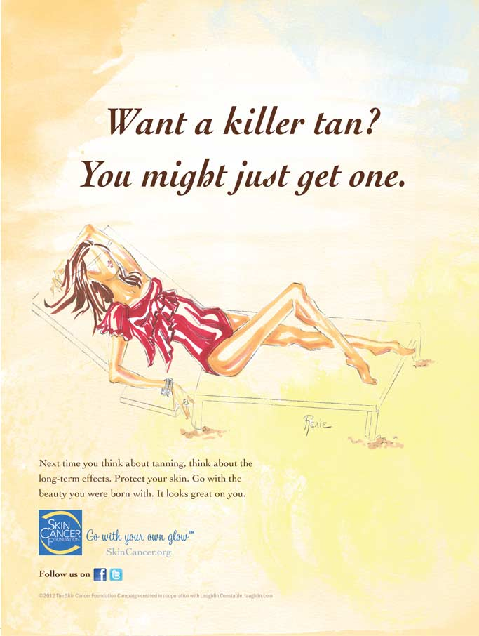

- What is the purpose of using short sentences throughout the visual? (1 mark)
- create emphasis
- demonstrate contrast
- establish audience
- imply stereotype

- Who is the sponsor? (1 mark)
- Cancer Foundation
- Facebook
- SkinCancer.org
- Twitter

- What is implied by the statement, “Want a killer tan? You might just get one.”? (1 mark)
- Long term tanning can cause major health problems.
- Moderate sun exposure is acceptable.
- Tanning will make you look and feel good.
- Wearing sunscreen prevents skin cancer.

- What is the purpose of the visual? (1 mark)
- to criticize
- to entertain
- to inform
- to reflect

Constructed Response
- Using two specific references identify and explain the tone of the visual. (6 marks)
_______________________________________________________________________________________________________________________________________________________________________________________________________________________________________________________________________________________________________________________________________________
_______________________________________________________________________________________________________________________________________________________________________________________________________________________________________________________________________________________________________________________________________________
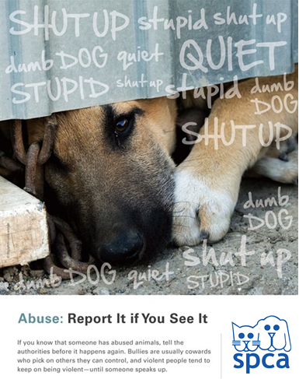

- Who is the intended audience of the visual? (1 mark)
- bullies
- dog owners
- general public
- SPCA

- What is the purpose of this visual? (1 mark)
- to advertise an organization
- to encourage adoption
- to provoke debate
- to raise awareness

- What is the tone of the visual? (1 mark)
- adoring
- enraged
- impartial
- unsympathetic

- What is the purpose of the dash in the phrase, “... and violent people tend to keep on being violent – until someone speaks up.”? (1 mark)
- to create suspense
- to provide a transition
- to establish mood
- to emphasize pause

Constructed Response (6 marks)
- With reference to two specific visual elements, explain the purpose of the text in the visual. (6 marks)
________________________________________________________________________________________________________________________________________________________________________________________________________________________________________________________________________________________________________________________________________________________________________________________________________________________________________________________________________________________________________________________________________________________________________________________________________________________________________________________________

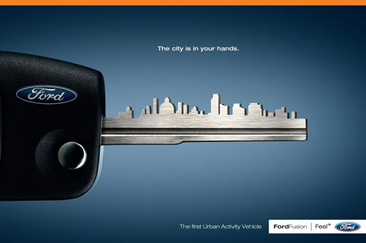

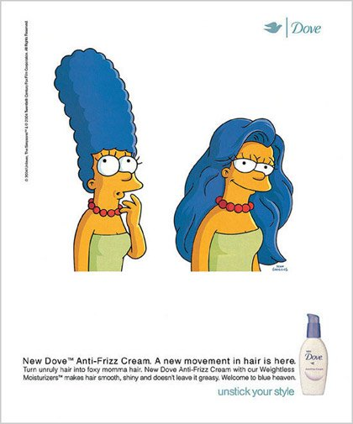



- What is the focal point of the visual? (1 mark)
- The date
- The fork
- The logo
- The word ‘Unicef’

- What mood is created in the visual? (1 mark)
- amused
- caring
- hostile
- serious

- What is the form of the visual? (1 mark)
- advertisement
- brochure
- poster
- web page

- What message is suggested by the fork with one short tine?
- Give a handout to someone who needs it.
- People do not eat enough because their forks are broken.
- The fork is hungry.
- When you are hungry you get angry and break things

Constructed Response
- With specific references, explain how two visual elements contribute to the overall message of the visual. (6 marks)
____________________________________________________________________________________________________________________________________________________________________________________________________________________________________________________________________________________________________________________________________________________________________________________________________________________________________________________________________________________________________________________________________________________________________________________________________________________________________________________________________________________________________________________________________________________________________________________________________________________________________________________________________________________________________________________________________________________________________________________________________________________________________________________________

Media Terms - Match each term to the correct definition.

advertisement  agenda  bias  blog  brochure  caption  commercial  demographic  endorsement  format/form  headline  icon  image | intent  lead  logo  mass media  media  motive  poster  product placement  propaganda  subtext  white space

1. ________________ A small booklet or pamphlet containing pictures and information about a product or service.

2. ________________ Introductory sentence in an article meant to grab the reader’s interest.

3. ________________ The reason for doing something, such as to make money, change opinion.

4. ________________ A communication form that employs sophisticated, often subtle methods of persuasion to not only get you to part with your money or win your support, but to play on your desires, emotions, and biases to change the way you think.

5. ________________ Examples of this include: web, print, etc. …and then how this is designed (8x11, 11x17 etc.).

6. ________________ An identifying symbol used to advertise and promote an organization, event, product or service. Usually, such symbols combine pictorial and textual elements in a distinctive manner.

7. ________________ Forms of public communication (such as newspaper, radio, television, information network, poster, or brochure) that are designed to reach large numbers of people.

8. ________________ A mental leaning or inclination; partiality; prejudice; bent.

9. ________________ A plan; goals to be achieved through advertising.

10. ________________ When media methods are used to communicate to thousands of people at the same time.

11. ________________ The heading, title or caption of a newspaper article; usually very attention- grabbing.

12. ________________ A web site on which an individual or group of users record opinions, information, etc. on a regular basis.

13. ________________ An attempt to sway popular opinion and beliefs through distortions of the truth or outright lies.

14. ________________ A testimonial strategy, where a famous person or organization publicly supports or promotes a product.

15. ________________ An advertising strategy in which commercial products or brands are placed within a play, film, broadcast program, video game or print medium for financial gain.

16. ________________ A title or brief explanation appended to an article, illustration, poster etc.; appear below the photo/visual.

17. ________________ A type of advertisement.

18. ________________ A form of communication that has varied purposes such as promoting events, presenting social commentary, persuading the viewer to purchase etc..

19. ________________ An underlying and often distinct theme or message in a piece of writing, conversation, ad, etc..

20. ________________ A representation of the external form of a person or thing in sculpture, painting, etc..

21. ________________ The portion of a page left unmarked.

22. ________________ The group of people to whom a message is directed – age, gender etc.

23. ________________ Purpose.

24. ________________ A person or thing regarded as a representative symbol of something.

