Novel Study
English 3202
‘Heist Society’ by Ally Carter
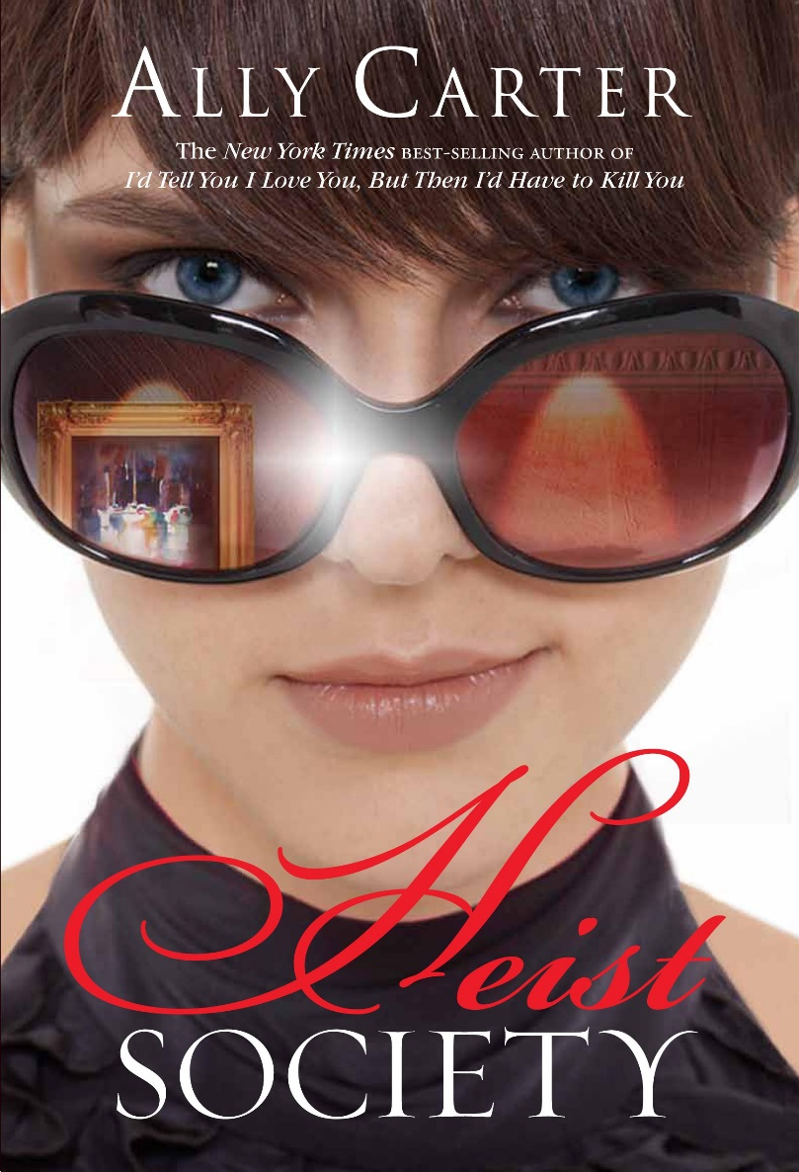

Name: _____________________________________________________
Due Date: ___________________________________________________

Information About The Novel
Author: Ally Carter
Series: First book in the Heist Society series.
Heist Society Series:
- Heist Society
- Uncommon Criminals
- Perfect Scoundrels
- Double Crossed: A Spies and Thieves Story’ (crossover with the Gallagher Girls series)
Published February 9th 2010 by Disney-Hyperion
Synopsis:
When Katarina Bishop was three, her parents took her on a trip to the Louvre… to case it. For her seventh birthday, Katarina and her uncle Eddie traveled to Austria… to steal the crown jewels. When Kat turns fifteen, she plans a con of her own – scamming her way into the best boarding school in the country, determined to leave the family business behind. Unfortunately, leaving “the life” for a normal existence proves harder than she expected. Soon, Kat’s friend and former co-conspirator, Hale, appears out of nowhere to bring Kat back into the world she has tried so hard to escape. But he has a good reason: a powerful mobster has been robbed of his priceless art collection and wants to get it back. Only a master thief could have pulled this job and Kat’s father isn’t just on the suspect life, he is the list. Caught between Interpol and a far more deadly enemy, Kat’s dad needs her help. For Kat, there is only one solution: track down the paintings and steal them back. So what if it’s a spectacularly impossible job? She’s got two weeks, a teenage crew and hopefully just enough talent to pull off the biggest heist in her family’s history – and, with luck, to steal her life back along the way.
Other Books by the Author:
Gallagher Girls Series
- I’d tell you I love you, but then I’d have to kill you
- Cross my heart and hope to spy
- Don’t judge a girl by her cover
- Only the good spy young
- Out of sight, out of time
- United we spy
Embassy Row Series
- All fall down
- See how they run

Before Reading
Look at the front cover and read the back cover. List the facts that you know or think you know about the book without having read it. You should have at least five facts or ideas about the novel.
________________________________________________________________________________________________________________________________________________________________________________________________________________________________________________________________________________________________________________________________________________________________________________________________________________________________________________________

At first glance, how do you feel about the novel? Why? Explain your answer in a full paragraph.
________________________________________________________________________________________________________________________________________________________________________________________________________________________________________________________________________________________________________________________________________________________________________________________________________________________________________________________________________________________________________________________________________________________________________________

Questions – Chapters 1-10
- What is the time and place of this book? How do you know?
__________________________________________________________________________________________________________________________________________________________________________________________________________________________________________________________________________________________________
- Name and describe the main character in the book. Include two points about her physically and two points about her personality.
________________________________________________________________________________________________________________________________________________________________________________________________________________________________________________________________________________________________________________________________________________________________________________________________________________________________________________________________________________
- Name and describe a minor character. Include two points about them physically and two points about their personality.
____________________________________________________________________________________________________________________________________________________________________________________________________________________________________________________________________________________________________________________________________________________________
- Describe the nature of the relationship between two characters you talked about in the questions above. Include their history together and details of their relationship. How is their relationship important to the story?
____________________________________________________________________________________________________________________________________________________________________________________________________________________________________________________________________________________________________________________________________________________________
Questions – Chapters 11-20
- What is a major conflict in this novel? How has the conflict developed at this point? How do you think the conflict will end?
____________________________________________________________________________________________________________________________________________________________________________________________________________________________________________________________________________________________________________________________________________________________
- Compare and contrast two characters and how they make decisions. Consider their actions and their behaviours.
____________________________________________________________________________________________________________________________________________________________________________________________________________________________________________________________________________________________________________________________________________________________
- Beyond the heist, what is the biggest challenge that Kat is facing? How can she over come it?
____________________________________________________________________________________________________________________________________________________________________________________________________________________________________________________________________________________________________________________________________________________________
- What role does Uncle Eddie play in the story? What does his home symbolize for Kat?
____________________________________________________________________________________________________________________________________________________________________________________________________________________________________________________________________________________________________________________________________________________________

Questions – Chapters 21-30
- Trust is important in the heist society. Why does Hale struggle to trust Nick? What other factors might make it hard for Hale to be nice about Nick?
____________________________________________________________________________________________________________________________________________________________________________________________________________________________________________________________________________________________________________________________________________________________
- Each section is introduced by how many days it is before or after the heist and the location. As a reader, how does this help in understanding the story?
____________________________________________________________________________________________________________________________________________________________________________________________________________________________________________________________________________________________________________________________________________________________
- How has the author been using humour, irony or symbolism? Give at least two examples.
____________________________________________________________________________________________________________________________________________________________________________________________________________________________________________________________________________________________________________________________________________________________
- Using the phrase ‘This is a story about…’ use five different words to describe this book. Explain your choices.
____________________________________________________________________________________________________________________________________________________________________________________________________________________________________________________________________________________________________________________________________________________________

Questions – Chapters 31-37
- What is the peak event or climax of this novel? How is it resolved?
____________________________________________________________________________________________________________________________________________________________________________________________________________________________________________________________________________________________________________________________________________________________

- What do you think of the line “I know rich… I think I’ll just aim for happy?”
____________________________________________________________________________________________________________________________________________________________________________________________________________________________________________________________________________________________________________________________________________________________

- What is the theme of this novel? How does the author develop this theme?
____________________________________________________________________________________________________________________________________________________________________________________________________________________________________________________________________________________________________________________________________________________________

- What did you learn from this novel?
____________________________________________________________________________________________________________________________________________________________________________________________________________________________________________________________________________________________________________________________________________________________

Activities of Choice – Pick Two

Complete two of the following activities. Attach your work to this booklet.

- How is the main character of this novel similar to a person that you know? Discuss in a three paragraph response.
- Have you had an experience similar to that of one of the characters in the novel? Write about that experience in a three paragraph response.
- Write a poem that describes the plot of the novel.
- Pretend that one of the characters of the novel has died. Write an obituary that will describe them.
- Design a map showing the locations of the novel.
- Describe the problems the main character in the novel encountered and tell how they solved these problems.
- Create a list of 25 words from the novel that you were previously unfamiliar with and define them.
- Cast the movie for this novel. Explain your choices for each character.
- Develop the soundtrack for this novel. Include eight to twelve songs and explain why you chose them.
- Draw a cartoon of your favourite scene from the novel.

Character Comparison

Compare Kat from ‘Heist Society’ with Katniss from ‘The Hunger Games’. Complete this Venn diagram for your answers.

Kat

Katniss
Theme

Theme is a major idea that a literary work is trying to teach the reader. Three major themes of this novel are:

Family Courage Choices

Pick one of the themes listed and write a thematic statement – a sentence which describes the lesson being taught.

Theme picked: ________________________________

Thematic Statement: _________________________________
_______________________________________________________________________________________________________________________________________

Personal Response:
Write about a time that this lesson was true to your life or to the life of someone you know. Using examples, discuss the process which helped you realize the lesson. You should write at least three paragraphs.
_______________________________________________________________________________________________________________________________________
_______________________________________________________________________________________________________________________________________
_______________________________________________________________________________________________________________________________________
_______________________________________________________________________________________________________________________________________
_______________________________________________________________________________________________________________________________________
_______________________________________________________________________________________________________________________________________
_______________________________________________________________________________________________________________________________________
_______________________________________________________________________________________________________________________________________
_______________________________________________________________________________________________________________________________________
_______________________________________________________________________________________________________________________________________
_______________________________________________________________________________________________________________________________________
_______________________________________________________________________________________________________________________________________

